Summary
The Global Logistics Management System (GLMS) is designed to help TechMove move away from its current manual processes and into a more modern, digital way of working. Instead of relying on spreadsheets, emails, and phone calls, the system brings everything including freight contracts, driver scheduling, invoicing, and client management into one central platform. This makes information easier to access, reduces errors, and improves overall efficiency and compliance.
The system is built for a range of users, including business teams such as logistics and finance, technical teams like developers and architects, as well as external users such as clients and drivers. To support these different needs, the solution follows a structured, layered architecture that covers business, data, application, and technology aspects. It is also designed using a cloud based, microservices approach, which allows the system to scale easily, remain reliable, and adapt as the business grows.

Architectural Framework Strategy: TOGAF
The TOGAF framework was selected because it provides a structured and comprehensive approach to designing complex enterprise systems such as GLMS.
Firstly, TOGAF’s Architecture Development Method (ADM) enables a step-by-step transformation from current manual processes to a fully integrated digital platform, which is critical for logistics environments with fragmented data sources.
Secondly, TOGAF supports alignment between business and IT, ensuring that logistics operations such as contract management, scheduling, and invoicing are directly supported by scalable applications and reliable data architectures.
Lastly, TOGAF promotes standardisation, scalability, and governance, which are essential for a global logistics company that must handle high transaction volumes, ensure compliance, and adapt to future growth.
ADM Phase | Focus Area | GLMS Application
Phase A | Architecture Vision | Build unified logistics platform replacing spreadsheets and emails.  Provide central visibility of contracts, service requests, and finance.
Phase B | Business Architecture | Contract management hub: to store Service Legal Agreements (SLAs), contracts and client details.  Service Request Processing: only valid contracts can be used.  Financial operations: Handling of various currencies and billing.  Stakeholder roles like clients, drivers and logistics managers.
Phase C | Data & Application Architecture | Contract Database: This is a central repository.  Service request system.  Client and SLA data storage  Currency conversion API integration  Applications: contract service, request service, finance service
Phase D | Technology Architecture | Cloud deployment with Azure.  Containerisation through Docker  Scaling services through Kubernetes.  API gateway  Secure authentication and integration services

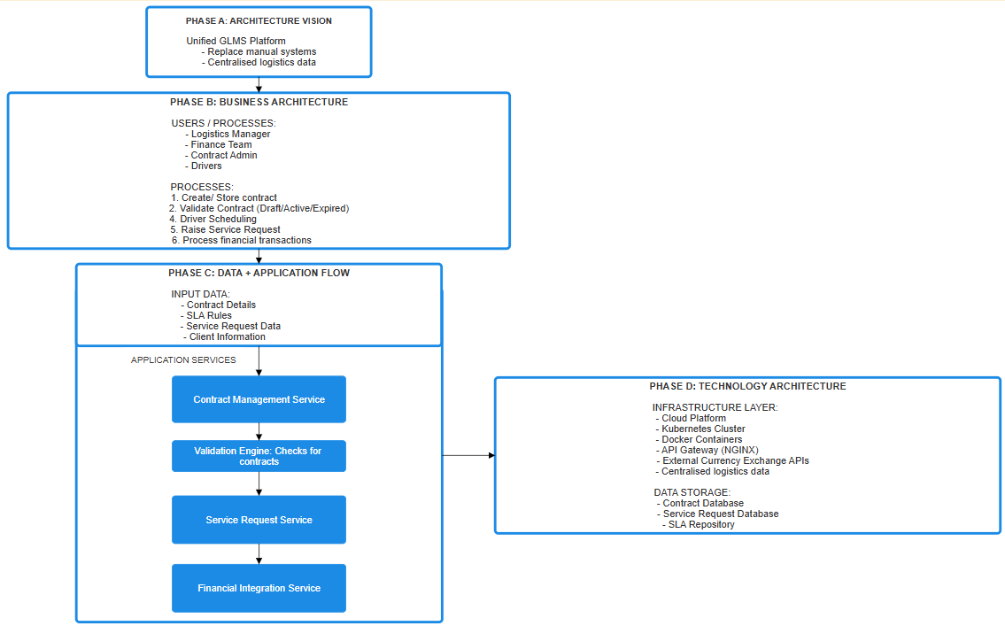

Non-Functional Requirements
Scalability
To handle a surge of 50,000 new contracts overnight, the GLMS is designed as a horizontally scalable, distributed system that can dynamically allocate resources, distribute traffic efficiently, and minimise database load through caching. This ensures that the system maintains performance and availability even under extreme workloads.
Horizontal scaling is achieved by deploying multiple instances of each microservice using Kubernetes (Burns et al., 2016). Instead of relying on a single powerful server, the system automatically increases the number of running service instances when demand rises. For example, the Contract Service may scale from a few instances under normal load to many more during peak periods. This allows the workload to be distributed across multiple containers, preventing bottlenecks and ensuring consistent response times.
To effectively handle a surge of 50,000 contract submissions, the GLMS utilises Layer 7 load balancing to intelligently distribute incoming traffic across multiple service instances. Load balancing algorithms such as round robin and least connections are applied to ensure efficient request distribution. Round robin distributes requests evenly across all available instances, making it suitable for general workloads, while least connections dynamically route traffic to the least busy instance, which is more effective during high traffic spikes. Additionally, health checks are implemented to continuously monitor service instances and automatically remove unhealthy nodes from the pool, ensuring uninterrupted service availability. The use of a reverse proxy further enhances performance by managing incoming requests and routing them efficiently to backend services. These techniques collectively ensure that no single service instance becomes overloaded, enabling the system to maintain performance, scalability, and reliability during peak loads (Microsoft, 2023; NGINX, Inc., 2023).
The GLMS is designed to achieve high availability by ensuring that system services remain operational with minimal downtime, even during failures or peak demand periods. This is achieved through the deployment of multiple service instances across containers, allowing the system to continue functioning even if one instance fails.
Caching is implemented using Redis to reduce the load on the database (Redis Ltd., 2023). Frequently accessed data such as active contracts, client details, and pricing rules are stored in memory, allowing for much faster retrieval compared to querying the database. By using a cache-aside pattern, the system first checks Redis before querying the database, significantly improving response times and reducing repeated database access during high-demand periods (Narumoto et al., 2017b).
The use of message queues enables asynchronous processing of high volumes of requests, ensuring that contract submissions are handled efficiently without overwhelming the system (Newman, 2021).
The GLMS is designed with a strong security architecture to protect sensitive logistics data, including contracts, client information, and financial records. Authentication and authorization mechanisms are implemented to ensure that only authorised users can access specific system functionalities, following role-based access control (RBAC). All communication between system components is secured using HTTPS to ensure data encryption in transit, while sensitive data stored in databases is encrypted at rest. API gateways and reverse proxies are used to enforce security policies, including request validation and rate limiting to prevent abuse. Additionally, container security practices such as image scanning and runtime protection are applied within the Kubernetes environment to minimise vulnerabilities. Continuous monitoring and logging are also implemented to detect and respond to potential security threats in real time (Newman, 2021; Microsoft, 2023).

References
Burns, B., Grant, B., Oppenheimer, D., Brewer, E. and Wilkes, J. (2016) Borg, Omega, and Kubernetes. ACM Queue, 14(1), pp. 70–93.
Microsoft (2023) Caching guidance. Available at: https://learn.microsoft.com/en-us/azure/architecture/best-practices/caching (Accessed: 11 April 2026).
NGINX, Inc. (2023) What is load balancing?. Available at: https://www.nginx.com/resources/glossary/load-balancing/ (Accessed: 11 April 2026).
Microsoft (2023) Availability patterns. Available at: https://learn.microsoft.com/en-us/azure/architecture/framework/resiliency/overview (Accessed: 11 April 2026).
Microsoft (2023) Security in microservices. Available at: https://learn.microsoft.com/en-us/azure/architecture/microservices/design/security (Accessed: 11 April 2026).
Narumoto, M., et al. (2017b) Caching guidance. Available at: https://learn.microsoft.com/en-us/azure/architecture/best-practices/caching (Accessed: 11 April 2026).
Newman, S. (2021) Building Microservices. 2nd edn. Sebastopol: O’Reilly Media.
Redis Ltd. (2023) What is Redis?. Available at: https://redis.io/docs/about/ (Accessed: 11 April 2026).
The Open Group (2018) TOGAF® Standard, Version 9.2. Available at: https://www.opengroup.org/togaf (Accessed: 11 April 2026).

